Adding and Deleting Tiles
You can customize what is accessible from a Homepage by adding, deleting or moving tiles.

How to Add a Tile to a Homepage
There are two options to add a tile:

Option 1: Navigate to the page and add as a tile to a Homepage
- Navigate to the page you want to add as a tile to a Homepage. (In this example: The user is navigating to the GT Action Center used for approving ePAF.)
- Click on the Action List menu icon in the upper right corner and select Add to Homepage.
- Select (choose) from available Homepages. (In this example: the user is adding the tile for the GT Action Center to the Customized Homepage)
- Click the Add button. You will get a message noting the tile has been successfully added.
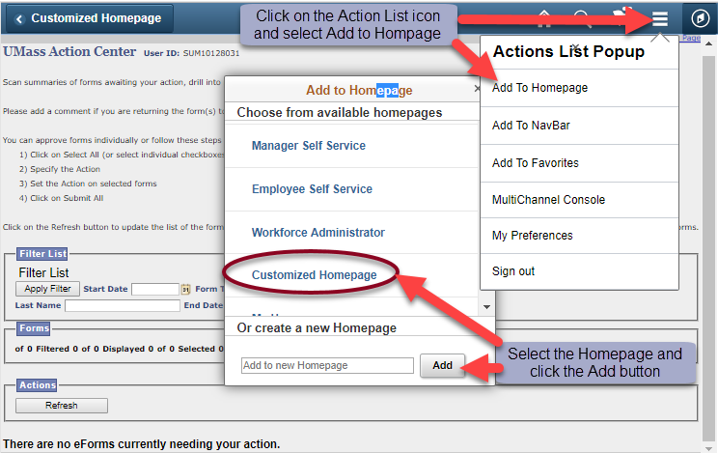
- To check that the tile did get added, navigate to Home, select the Homepage you added the tile to, and the new tile should be available. (In this example: GT Action Center has been added to the Customized Home Page).
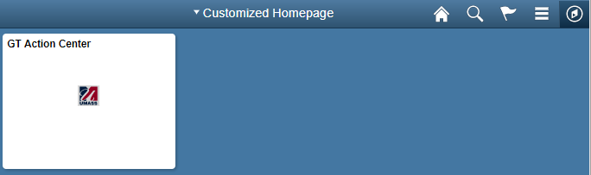

Option 2: Navigate to Personalize Home Page and then add a tile
- Navigate to a Fluid Homepage
- Click on the Action List menu icon in the upper right corner.
- Select the Personalize Homepage Menu option from the list.
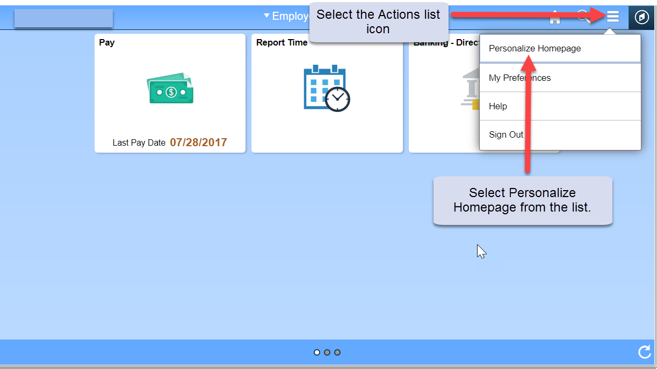

- Click on the “Add Tile” button in the upper right corner. The Add Tile pop-up window is displayed.
- The search bar may be used to locate a tile/page or you can navigate to the menu item to be added. Click the Save button in the top right corner to complete or click the Cancel button in the upper left corner to exit the page without saving your changes.
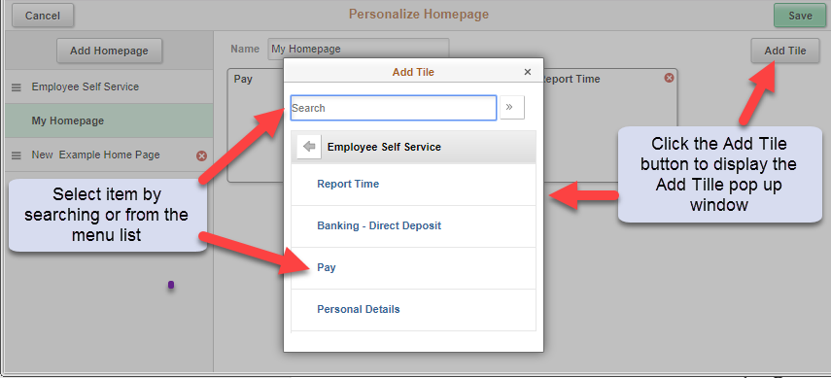

How to Delete a Tile
- Navigate to a Fluid Home Page.
- Click on the Action List menu icon in the upper right corner.
- Select the Personalize Homepage menu option from the list.
- Select the Homepage to remove the tile from. (In this example, the user selected My Homepage.)
- On a Homepage, each tile is represented as a square. Click the red ‘X’ in the upper right corner of the tile to be deleted.
- Click the Save button in the upper right corner of the page or click on the Cancel button.
